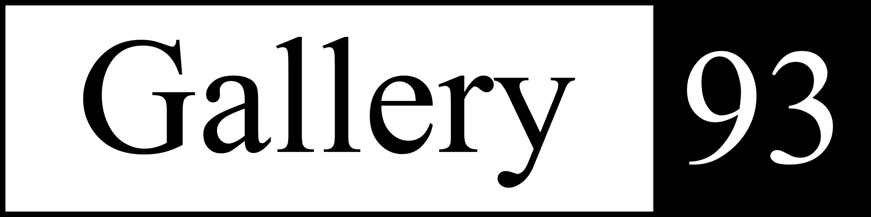

Gallery 93 at the Brookline Senior Center

FOR IMMEDIATE RELEASE:

New Exhibit: Abstraction Observed: Paintings by Mark Chabourne
Dec 8, 2025 - through Feb 27, 2026

Brookline, Massachusetts, Gallery 93 at the Brookline Senior Center is pleased to present
Abstraction Observed, paintings by Mark Chadbourne. The exhibit runs from Dec 8, 2025- through Feb 27, 2026. A reception for the artists will be held on Thursday January 15 from 1-2:30 pm with an artists’ talk held at 2:00 pm. Gallery 93, located at 93 Winchester Street, Brookline, MA, is open from 8:30-5:00, Monday through Friday.

Mark Chadbourne started his life steeped in an artistic family. Costume design, calligraphy, inlaid mahogany furniture and watercolor painting were all art forms that Mark grew up around. It is not surprising that he began his college years studying art. Chadbourne studied art at Syracuse University where he earned a BA in fine art painting and first began his hard-edge painting style as a student there. After many years in the financial industry Chadbourne is able to devote his time once again to his love of painting geometric forms often inspired by contemporary architecture. Lines, color, and movement draw us in and enliven the space with both flat appearing surfaces and illusions of depth. Mark states: “My paintings reflect my fascination and attraction with non-representational art. In each painting my intent is to create a strong visual statement where the viewer can find balance in the off balance and in the asymmetry that I have created and painted.”

Biography:

Mark Chadbourne graduated from Syracuse University with a BA (cum laude) in Fine Arts, where I started with my geometric hard edged painting style. After many years in the financial services industry, I have returned to my childhood passion of creating artwork. Over the past several years I have joined several local arts organizations and have exhibited my paintings over 50 times in the past seven years. I have been honored to be selected for several juried exhibits such as the Frances N. Roddy show at the Concord (MA) art center and with other juried and non-juried exhibitions sponsored by the Newton and Cambridge art associations.

Please visit his web site for the latest work and exhibition information – markchadbourne.com

Contact:
Hilary Tolan, Curator, Gallery 93
781-420-6018, hilarytolan@gmail.com

Jamie Jensen, Program Manager, Brookline Senior Center
617-730-2753, jjensen@brooklinema.gov

